**Annual Complaint Handling and Improvement Report 2024 and 2025**

As the chairman of the Great Missenden and District Abbeyfield Board of trustees, it is my responsibility to monitor and address any complaints or concerns that our 15 residents may raise with us. In the previous year, from April 2023 until March 2024, and in this last year from April 2024 until March 2025 I am pleased to say there were no formal complaints. Our staff do their utmost to ensure that residents are happy, living with us and that all their needs are met within their power.

Clearly we are pleased that there have been no complaints, but staff do not rest on their laurels and constantly strive to improve the lives of our residents and maintain high standards in everything we offer.

The Board will continue to ensure that all our staff are fully trained to handle any complaint in a professional, sensitive, effective and timely way. The Board and staff will continue to develop new and improve existing services for our residents in a culture of openness and honesty, ensuring that we learn from past experience.

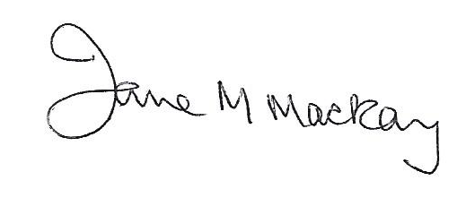

Jane M Mackay

Chairman

March 2025