**Annual Complaint Handling and Improvement Report 2024 and 2025**

At Abbeyfield Great Missenden & District Society we are all committed to making sure that the services we offer are of the highest standard and responsive to the needs of our 15 residents. To ensure that we meet our commitment, we are improving the way in which we will respond to any complaints and concerns raised by our residents and ensure that lessons, if any are learnt.

I am pleased to report that from April 2023 until March 2024 and in this last year April 2024 until March 2025 there were no complaints from residents and so none were referred to the Housing Ombudsman. There are none recorded in this report. Which though pleasing, we are not complacent and have agreed to take the following steps to ensure that all staff are fully trained and understand the need for a positive culture, which takes account of previous experience and lessons learnt so that residents can feel comfortable should a situation arise, when they may wish to make a complaint.

We intend to:

* Train all staff on effective handling of complaints, so that the team work together and install a positive culture of active listening and learning from past behaviours, which will then improve the service we offer to our residents.
* We have updated our complaints procedures. Our complaints, concerns & Compliments policy was updated in Jan 2025 and will be reviewed every 3 years, subject to any regulatory or legislative updates. Residents will continue to receive an annual questionnaire to complete which will now include the option of making a complaint.
* Devote time at each Board meeting to discuss and review any complaints.
* Nominate a Board member to work with the manager, to follow up any actions required, as an outcome of our self-assessment, which we undertook against the Housing Ombudsman’s Complaint Handling Code, prior to it becoming official in April 2025.
* Publish the outcome of this review in an accessible format for all our residents, and mark our progress made, as well as highlighting any areas for future improvement.
* Ensure that the outcome of the review features at our annual open meeting for residents and their families and sponsors.
* Publish the Annual Complaints review on our website

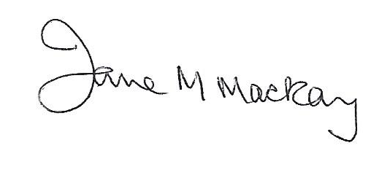

Jane M Mackay

Chairman

March 2025